**Humming Bee Garden Water Sprinkler System**

**By:**

**Vinay Sagar Gonabavi**

**Shivam Varma**

**Team: 15**

**Sequence Diagrams:**

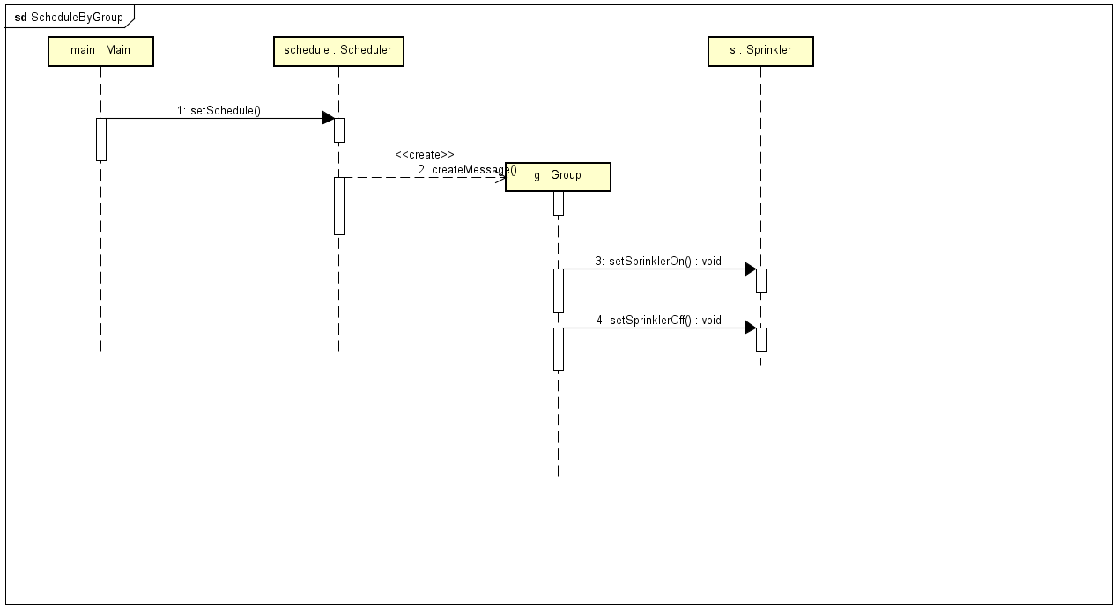

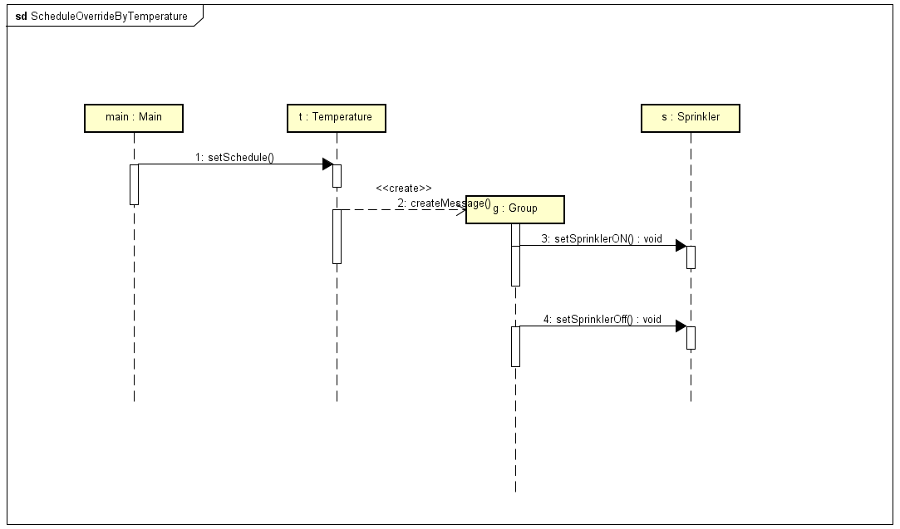

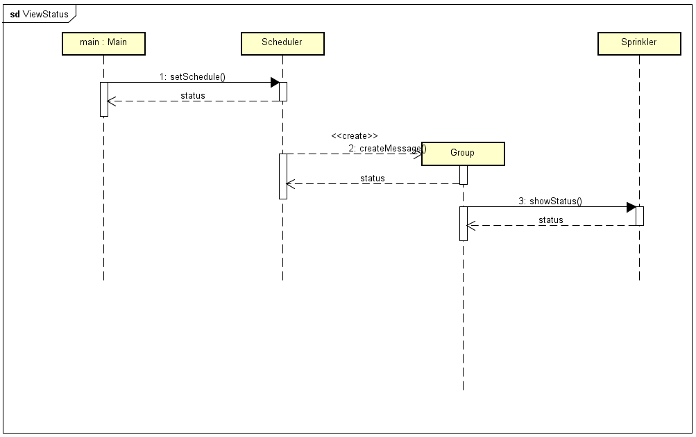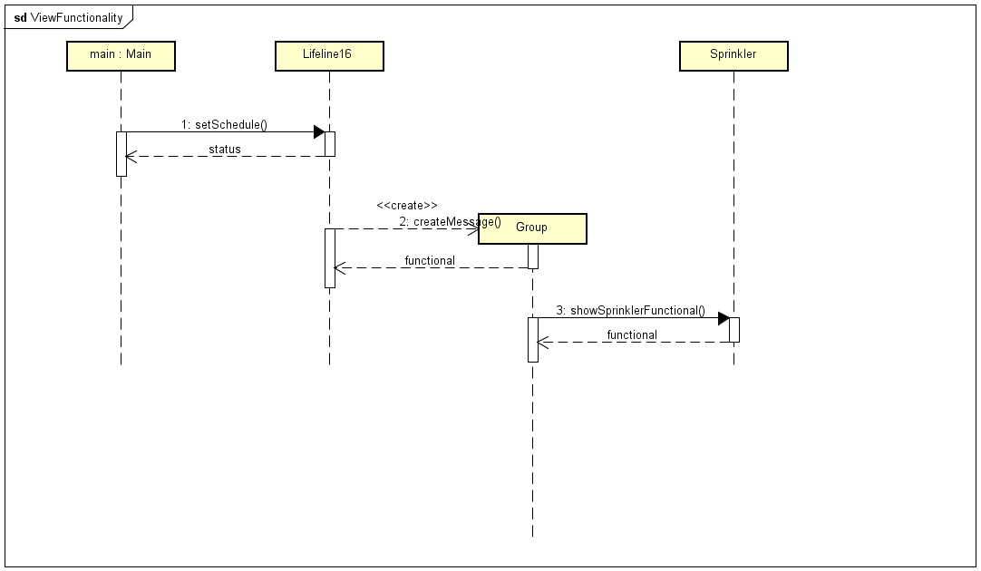

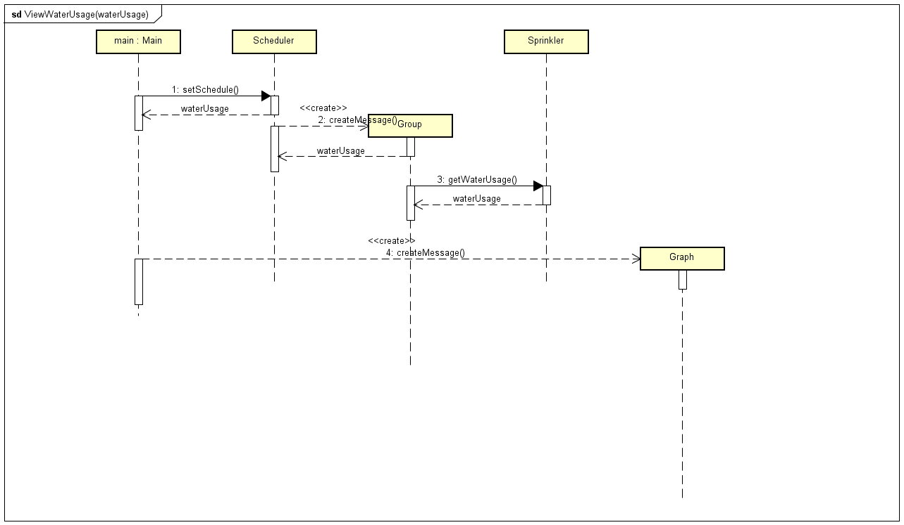

**Class Diagram: (Detailed View in .Astah File)**

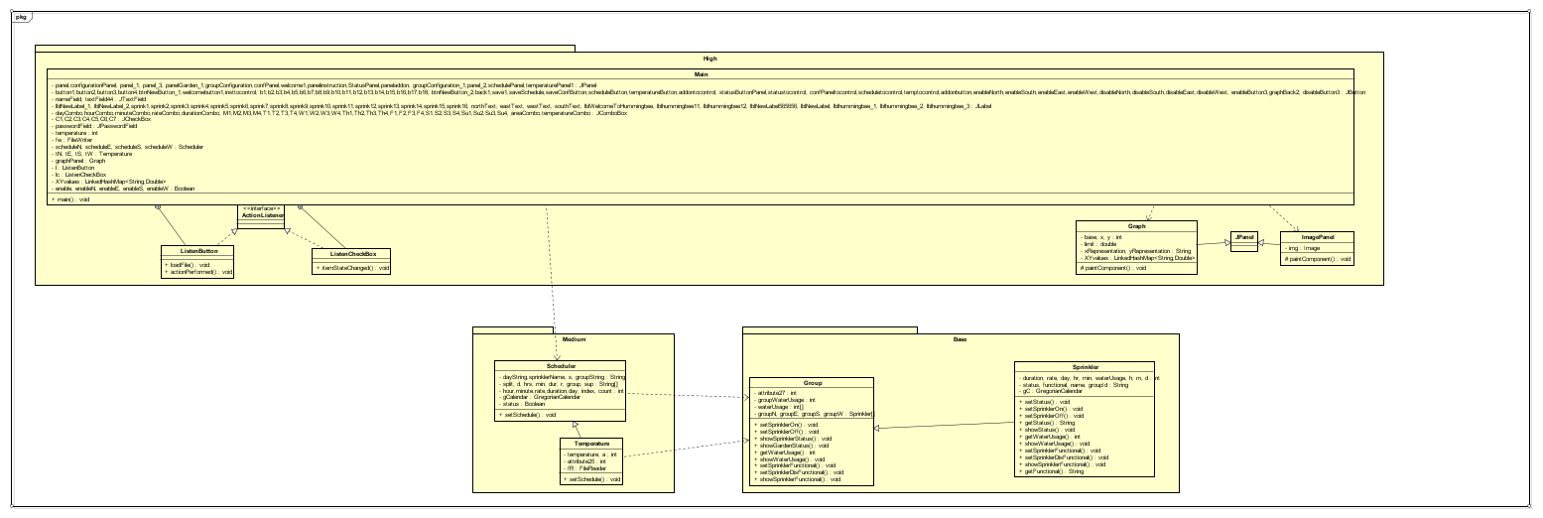

**Package Diagram:**

